**Post analysis**

Analysing user experience after playing our stress buster game

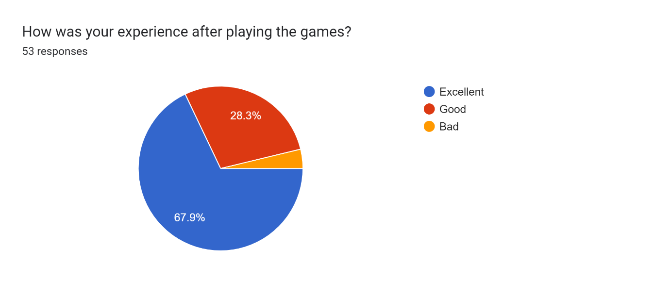

From this it is identified that most of the user’s(67.9%) have excellent experience in relieving their stress and and around 28% people feel it good to play the game

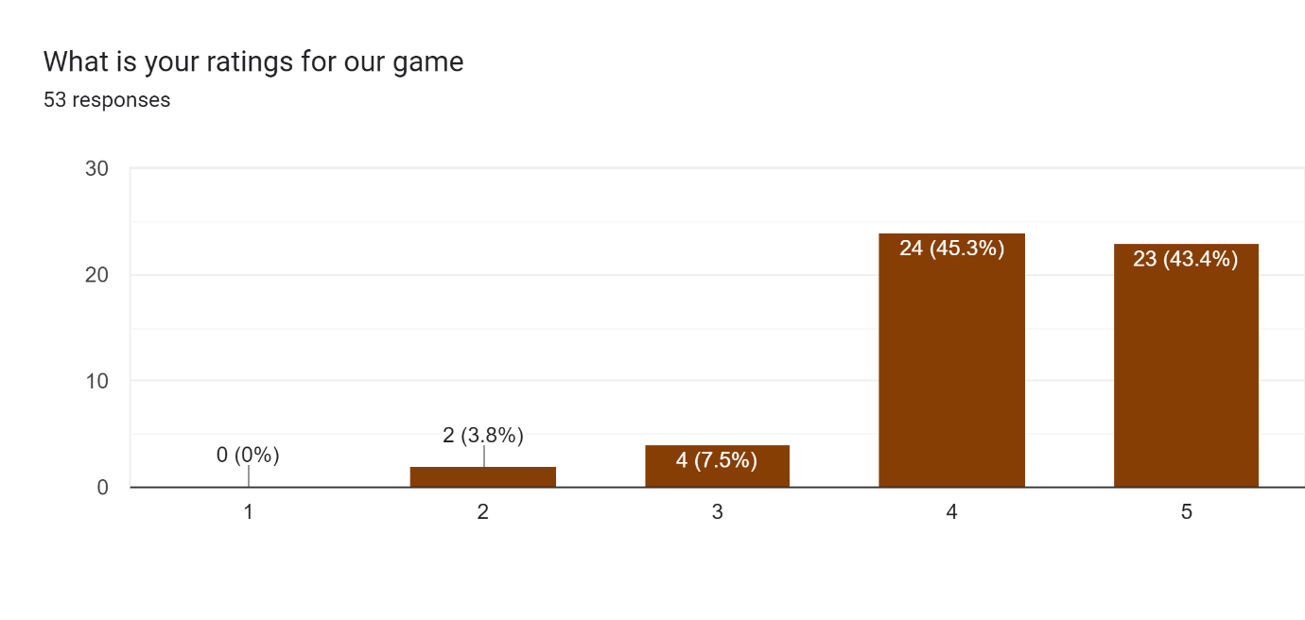

From this survey it is identified that almost all the user rate the game between 4 and 5.Hence we concude that they have good experience in playing the games

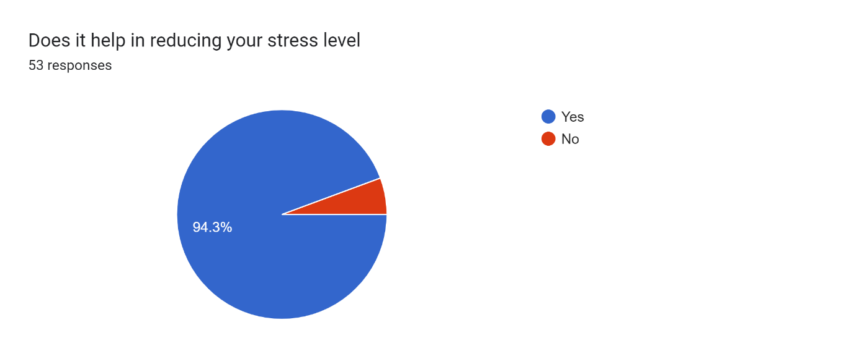

From this it is identified that almost 94% of the users found that the stress buster game helpings in reducing the stress significantly.